**Gateway Technical College**

DATABASES

152-080

Unit 8 Assignment

# Introduction

In the Lab in Unit 5 you created the database **Video** and the 5 tables for this database. In this lab you will **ALTER** the tables and add the table constraints that are defined in the tables below. For each of the tables add the required constraints as outlined below (mark in red).

Example: On the **Members** table add the default constraint to the ***JoinDate*** to use the system date.

Verify that all of the tables now are complete with the appropriate fields, types and lengths as well as any default values, keys and constraints.

The following diagram is a logical design of the entities and attributes for the **Video** database.

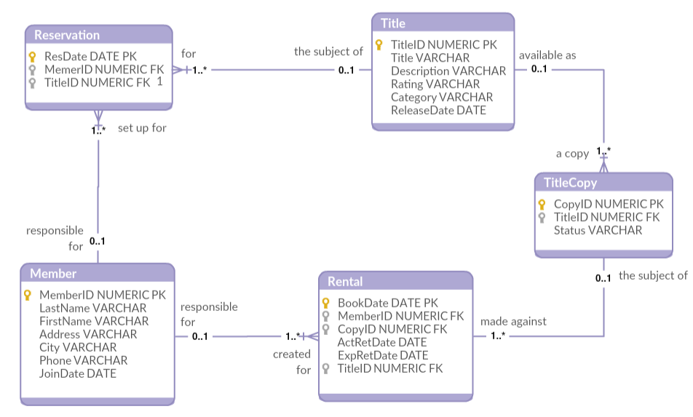

***Note****: This diagram is for reference only and it may not contain every object as described/required in the assignment. You're not required to know what the symbols mean or how they're generated. Also, disregard any text mentioned outside of the boxes. Focus on the "relationships".*

MAKE SURE document your work and your commands work before you past them into the document. Do not use the GUI interface to alter these actions.

Once completed, attach this completed word document to this assignment for grading.   Each question will be worth 5 points.

Use the **Discussion Forum** if you have any questions regarding the how to approach this assignment. You can also email your instructor directly for assistance if you have any questions.

Save your submission as ***lastnameFirstname_assign6.docx*** and submit it in the unit *Apply* section of the course.

# Instructions

You are to complete the following actions in the database that you created named **Video** in the previous lab. The syntax must work. For each question below – paste in print screens of your query window showing the command and the functioning output.

Use the **ALTER** command to alter the tables and add the table constraints that are defined in the tables below. DO NOT use the SSMS GUI interface to complete these actions.

1. Table Name: **Member**

**YOUR COMMAND WAS:**

|  |
| --- |
| ALTER Table Member  ADD Constraint JoinDate  Default GetDate() FOR JoinDate |

|  |  |  |  |  |  |  |  |
| --- | --- | --- | --- | --- | --- | --- | --- |
| **Colum Name** | MemberID | LastName | FirstName | Address | City | Phone | JoinDate |
| **Key Type** | PK |  |  |  |  |  |  |
| **Null/Unique** | NN | NN |  |  |  |  | NN |
| **Check** |  |  |  |  |  |  |  |
| **Default Value** |  |  |  |  |  |  | **System Date** |
| **FK Ref Table** |  |  |  |  |  |  |  |
| **FK Ref Column** |  |  |  |  |  |  |  |
| **Data Type** | NUMERIC | VARCHAR | VARCHAR | VARCHAR | VARCHAR | VARCHAR | DATE |
| **Length** | 10 | 25 | 25 | 100 | 30 | 15 |  |

2. Table Name: **Title**

**YOUR COMMAND(S) WAS/WERE:**

|  |
| --- |
| ALTER Table Title  ADD Constraint Rating  CHECK(Rating = 'G' OR Rating = 'PG' OR Rating = 'R' OR Rating = 'NC17' OR Rating = 'NR')  ALTER Table Title  ADD Constraint Category  CHECK(Category = 'Drama' OR Category = 'Comedy' OR Category = 'Action' OR Category = 'Child' OR Category = 'Scifi' Or Category = 'Documentary') |

|  |  |  |  |  |  |  |
| --- | --- | --- | --- | --- | --- | --- |
| **Colum Name** | TitleID | Title | Description | Rating | Category | ReleaseDate |
| **Key Type** | PK |  |  |  |  |  |
| **Null/Unique** | NN | NN | NN |  |  |  |
| **Check** |  |  |  | **G,**  **PG,**  **R,**  **NC17,**  **NR** | **Drama,**  **Comedy,**  **Action,**  **Child,**  **Scifi,**  **Documentary** |  |
| **Default Value** |  |  |  |  |  |  |
| **FK Ref Table** |  |  |  |  |  |  |
| **FK Ref Column** |  |  |  |  |  |  |
| **Data Type** | NUMERIC | VARCHAR | VARCHAR | VARCHAR | VARCHAR | DATE |
| **Length** | 10 | 60 | 400 | 4 | 20 |  |

3. Table Name: **TitleCopy**

**YOUR COMMANDS WERE:**

|  |
| --- |
| ALTER Table TitleCopy  ADD Constraint FK_TitleID  Foreign Key (TitleID) References Title(TitleID)  ALTER Table TitleCopy  ADD Constraint Status  CHECK(Status = 'Available' OR Status = 'Destroyed' OR Status = 'Rented' OR Status = 'Reserved') |

|  |  |  |  |
| --- | --- | --- | --- |
| **Colum Name** | CopyID | TitleID | Status |
| **Key Type** | PK | **FK** |  |
| **Null/Unique** | NN | NN, U | NN |
| **Check** |  |  | **Available,**  **Destroyed,**  **Rented,**  **Reserved** |
| **Default Value** |  |  |  |
| **FK Ref Table** |  | **Title** |  |
| **FK Ref Column** |  | **TitleID** |  |
| **Data Type** | NUMERIC | NUMERIC | VARCHAR |
| **Length** | 10 | 10 | 15 |

4. Table Name: **Rental**

**YOUR COMMANDS WERE:**

|  |
| --- |
| ALTER Table Rental  ADD Constraint BookDate  Default GetDate() For BookDate  ALTER Table Rental  ADD Constraint FK_MemberID  Foreign Key (MemberID) References Member(MemberID)  ALTER Table Rental  ADD Constraint FK_CopyID  Foreign Key (CopyID) References TitleCopy(CopyID)  ALTER Table Rental  ADD Constraint ExpRetDate  Default GetDate() + 2 For ExpRetDate  ALTER Table Rental  ADD Constraint FK__TitleID  Foreign Key (TitleID) References TitleCopy(TitleID) |

|  |  |  |  |  |  |  |
| --- | --- | --- | --- | --- | --- | --- |
| **Colum Name** | BookDate | MemberID | CopyID | ActRetDate | ExpRetDate | TitleID |
| **Key Type** | PK | **FK** | **FK** |  |  | **FK** |
| **Null/Unique** | NN | NN | NN |  |  | NN |
| **Check** |  |  |  |  |  |  |
| **Default Value** | **System**  **Date** |  |  |  | **System Date**  **+ 2 days** |  |
| **FK Ref Table** |  | **Member** | **TitleCopy** |  |  | **TitleCopy** |
| **FK Ref Column** |  | **MemberID** | **CopyID** |  |  | **TitleID** |
| **Data Type** | DATE | NUMERIC | NUMERIC | DATE | DATE | NUMERIC |
| **Length** |  | 10 | 10 |  |  | 10 |

5. Table Name: **Reservation**

**YOUR COMMANDS WERE:**

|  |
| --- |
| ALTER Table Reservation  ADD Constraint FK__MemberID  Foreign Key (MemberID) References Member(MemberID)  ALTER Table Reservation  ADD Constraint FK__TitleID  Foreign Key (TitleID) References Title(TitleID) |

|  |  |  |  |
| --- | --- | --- | --- |
| **Colum Name** | ResDate | MemberID | TitleID |
| **Key Type** | PK | **FK** | **FK** |
| **Null/Unique** | NN | NN, U | NN |
| **Check** |  |  |  |
| **Default Value** |  |  |  |
| **FK Ref Table** |  | **Member** | **Title** |
| **FK Ref Column** |  | **MemberID** | **TitleID** |
| **Data Type** | DATE | NUMERIC | NUMERIC |
| **Length** |  | 10 | 10 |

6. Insert the following member into the Member table.

**YOUR COMMAND WAS:**

|  |
| --- |
| INSERT Into Member  Values  (123, 'Jones', 'Tom', '1400 South 27 St', 'Milwaukee', '414-516-8244', '2/12/2018') |

|  |  |  |  |  |  |  |
| --- | --- | --- | --- | --- | --- | --- |
| MemberID | LastName | FirstName | Address | City | Phone | JoinDate |
| 123 | Jones | Tom | 1400 South 27 St | Milwaukee | 414-645-8244 | 2/12/2018 |

Were there errors? If so, explain.

7. Insert the following movie title into the Title table.

**YOUR COMMAND WAS:**

|  |
| --- |
| INSERT Into Title  Values  (101, 'Harry Potter', 'A series of fantasy novels that chronicle the life of a young wizard, Harry Potter, and his friends Hermione Granger and Ron Weasley.',  'G', 'Scifi', '11/14/2001') |

|  |  |  |  |  |  |  |
| --- | --- | --- | --- | --- | --- | --- |
| TitleID | Title | | Description | Rating | Category | ReleaseDate |
| 101 | Harry Potter | A series of fantasy novels that chronicle the life of a young wizard, Harry Potter, and his friends Hermione Granger and Ron Weasley. | | G | Scifi | 11/14/2001 |

Were there errors? If so, explain.

8. Insert another movie title below into the Title table.

**YOUR COMMAND WAS:**

|  |
| --- |
| INSERT Into Title  Values  (101, 'Gremlins', 'A strange creature which spawns other creatures who transform into small, destructive, evil monsters.',  'NC12', 'Scifi', '6/8/1984') |

|  |  |  |  |  |  |
| --- | --- | --- | --- | --- | --- |
| TitleID | Title | Description | Rating | Category | ReleaseDate |
| 101 | Gremlins | A strange creature which spawns other creatures who transform into small, destructive, evil monsters. | NC12 | Scifi | 6/8/1984 |

Were there errors? If so, explain.

Yes, because thers is another value that occupies 101 as the TitleID

9. Insert the following rental data into the Rental table.

**YOUR COMMAND WAS:**

|  |
| --- |
| INSERT Into Rental  Values  ('2/10/2018', 123, 555, '2/5/2018', '2/22/2018', 101) |

|  |  |  |  |  |  |
| --- | --- | --- | --- | --- | --- |
| BookDate | MemberID | CopyID | ActRetDate | ExpRetDate | TitleID |
| 2/10/2018 | 123 | 555 | 2/5/2018 | 2/22/2018 | 101 |

Were there errors? If so, explain.

no

10. Insert the following data into the TitleCopy table.

**YOUR COMMAND WAS:**

|  |
| --- |
| INSERT Into TitleCopy  Values  (555, 101, 'Available') |

|  |  |  |
| --- | --- | --- |
| CopyID | TitleID | Status |
| 555 | 101 | Available |

Were there errors? If so, explain.

11. Repeat Step 9 above. Were there errors? If so, explain.

The next 2 steps (#12 & #13) require that Step 9 above was successful. If it was not successful, make sure you go back and fix it before continued.

12. Delete the same data you had just inserted in Step 10 above.

**YOUR COMMAND WAS:**

|  |
| --- |
| DELETE FROM TitleCopy WHERE CopyId = 555 |

Explain why it failed.

|  |
| --- |
| Since the values in Rental Table rely on it, it will not drop the data |

13. Show the steps that must be taken in order to successfully delete the data in Step 12.

**YOUR COMMAND WAS:**

|  |
| --- |
| DELETE FROM Rental WHERE CopyId = 555  DELETE FROM TitleCopy WHERE CopyId = 555 |

14. Verify that all of the tables were created correctly with the appropriate constraints and relationships. Create an ERD showing all tables and their relationships.

**YOUR VERFICATIONS:**

|  |
| --- |
|  |

*Hint: Below is an example of an ERD showing relationships and constraints (FK) between tables.*

